**Provision a MS SQL Database Instance in Azure**

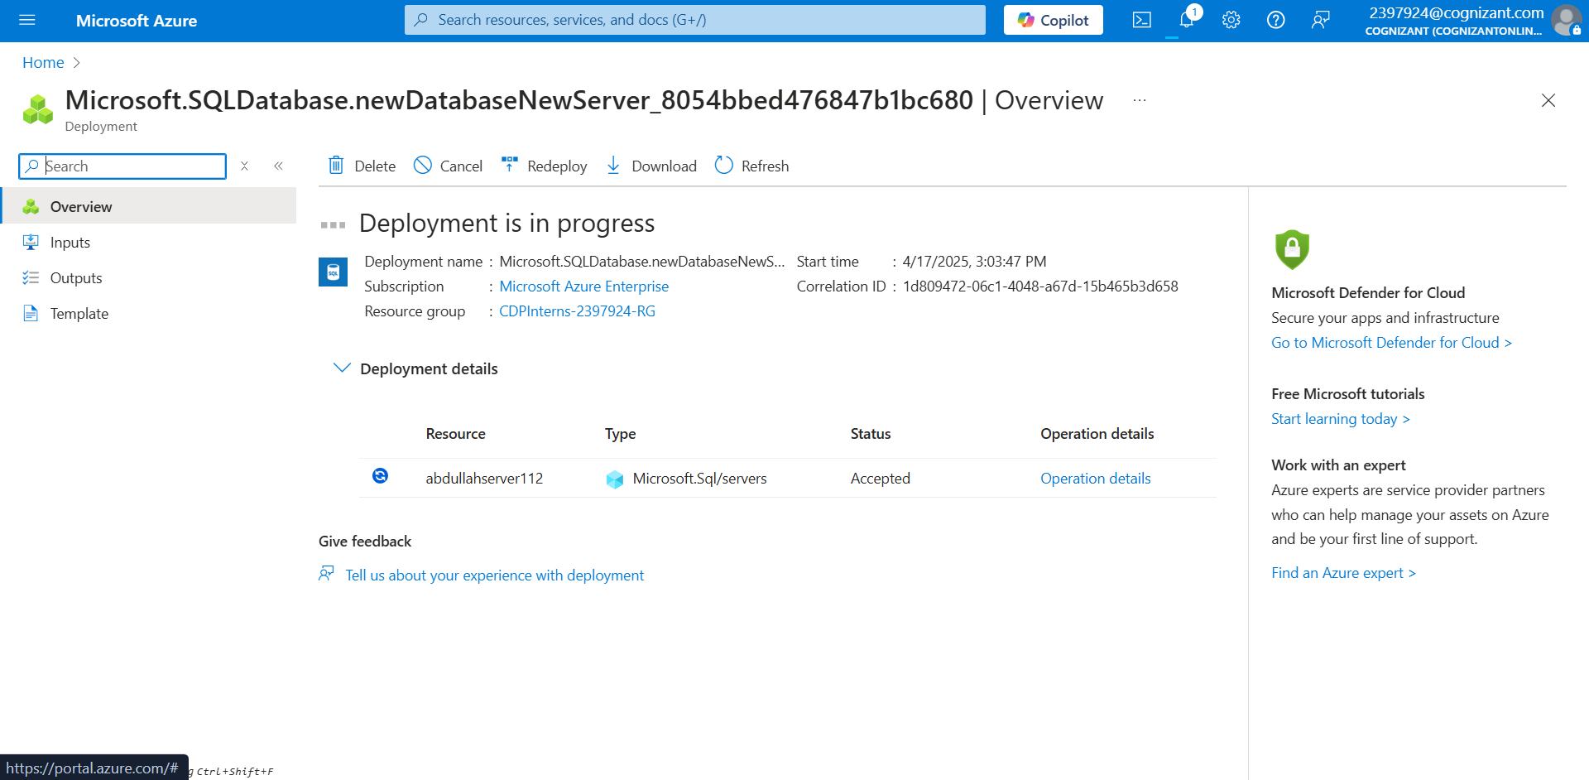

Creating a Geo Replica

Replica Created

Turned on the data encryption

Powershell creation of DB

Creating a Server

Creating a DB